# Design 2

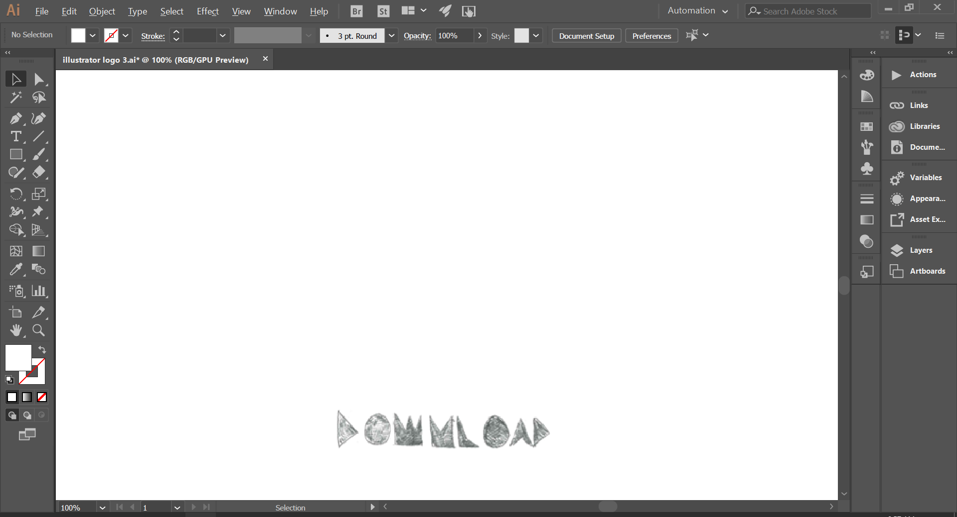

First, I put in one of the fonts that I would be using in this logo. I imported the image so that I could use it to copy. The alternative would be to enlarge the image even more, but as this is a sketch and the lines aren’t straight, it would be easier to use the image as inspiration, so the lettering looks the same.

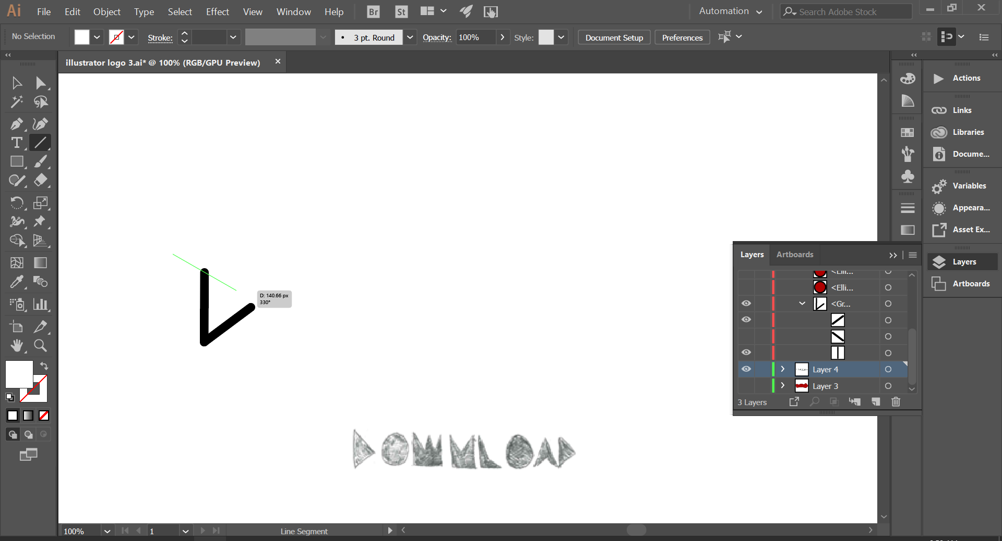

Here we can see the start of creating the fonts. Nearly every letter is created using the **line tool**, with the letter’s “O” being the only exception, which were created using the circle tool. I would normally trace over the letters, however in this case the letters were hand drawn and weren’t perfectly straight, meaning tracing would be difficult. I instead just copied the image instead of tracing it. in this case its quite easy, as every letter other than the ‘O’s are made out of straight lines.

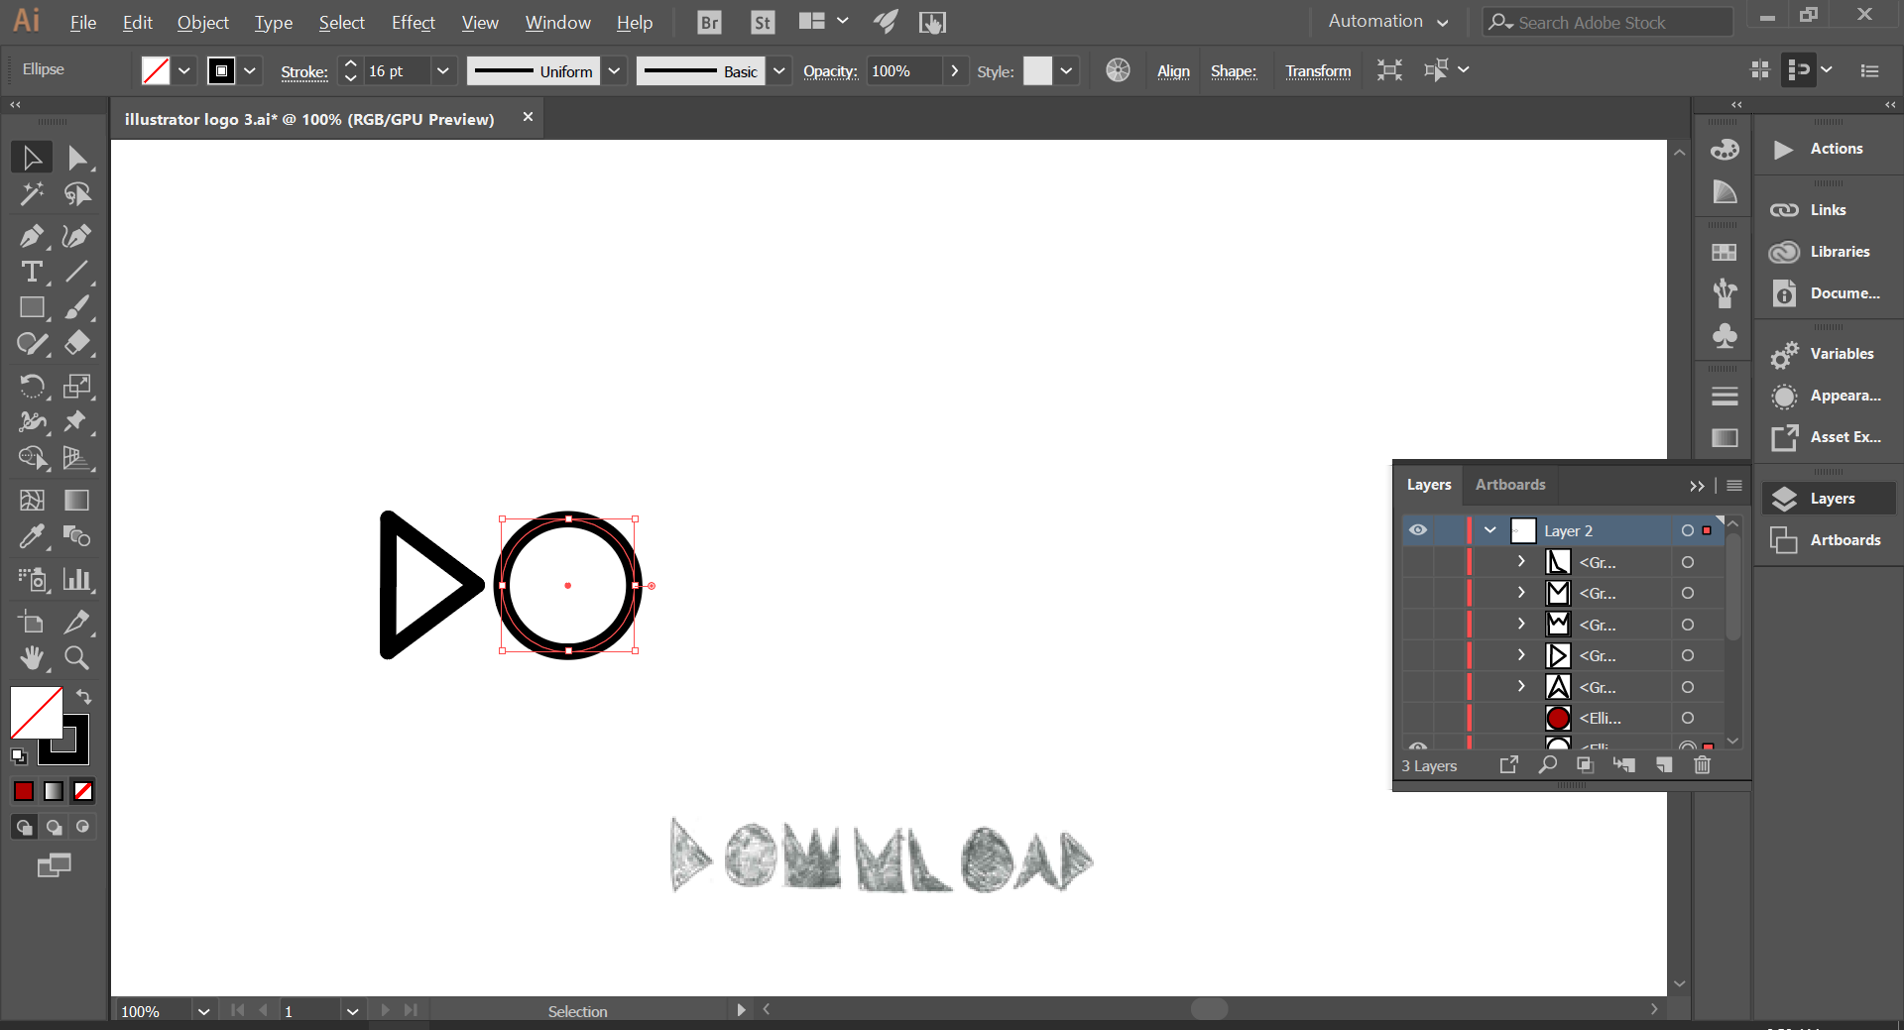

This letter is the easiest to create, because its created using the **circle tool**, and requires no modification apart from the **stroke size** of the outline. I made the circle **transparent**, so that it shows the background through it.

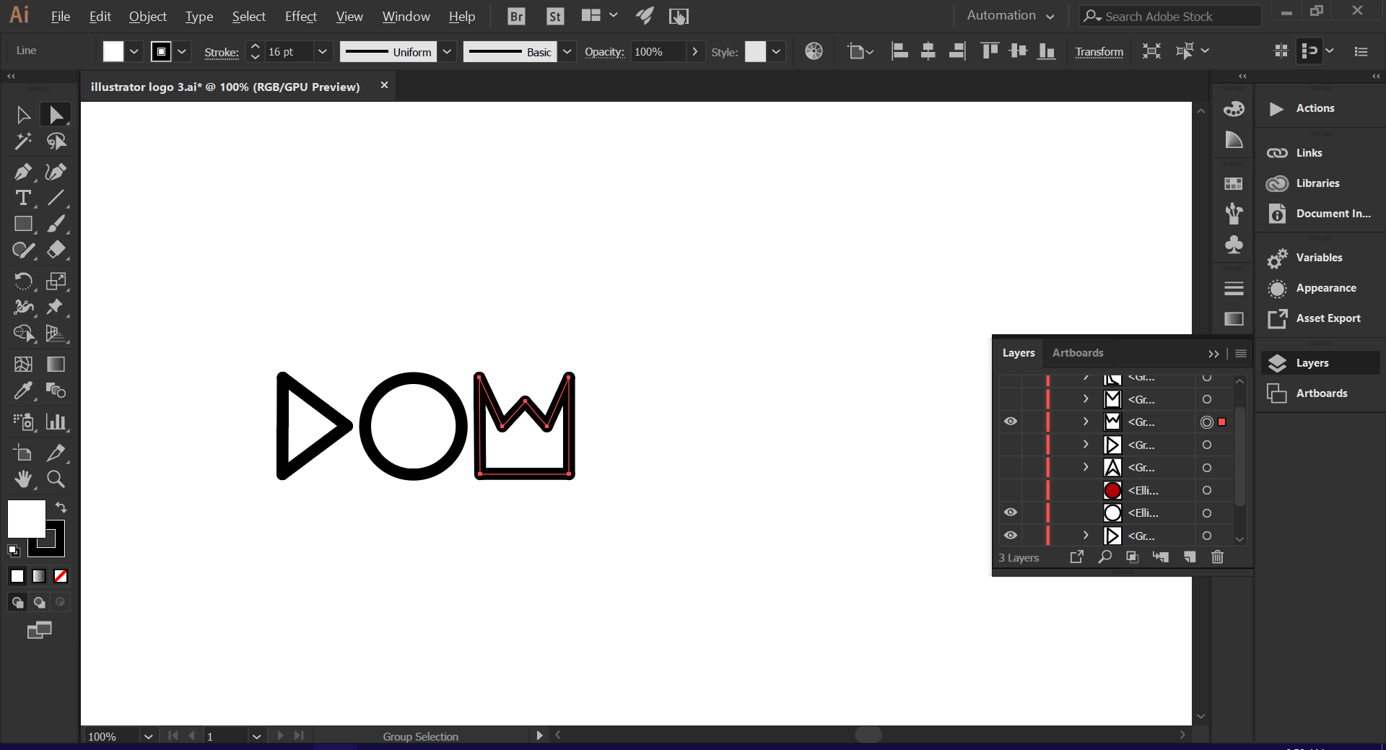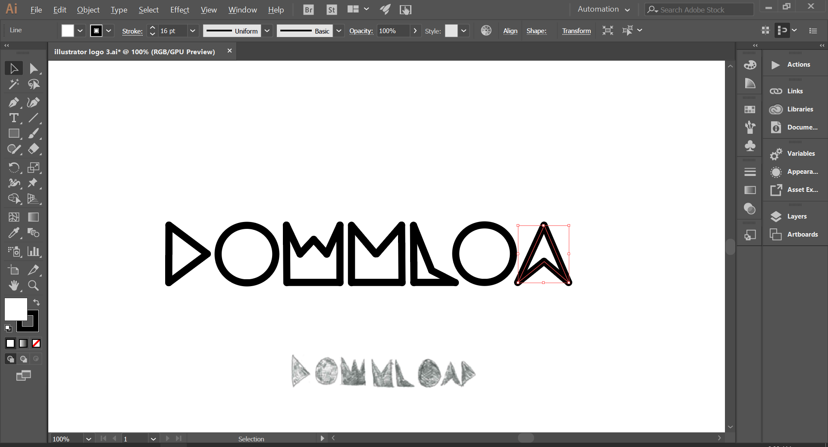

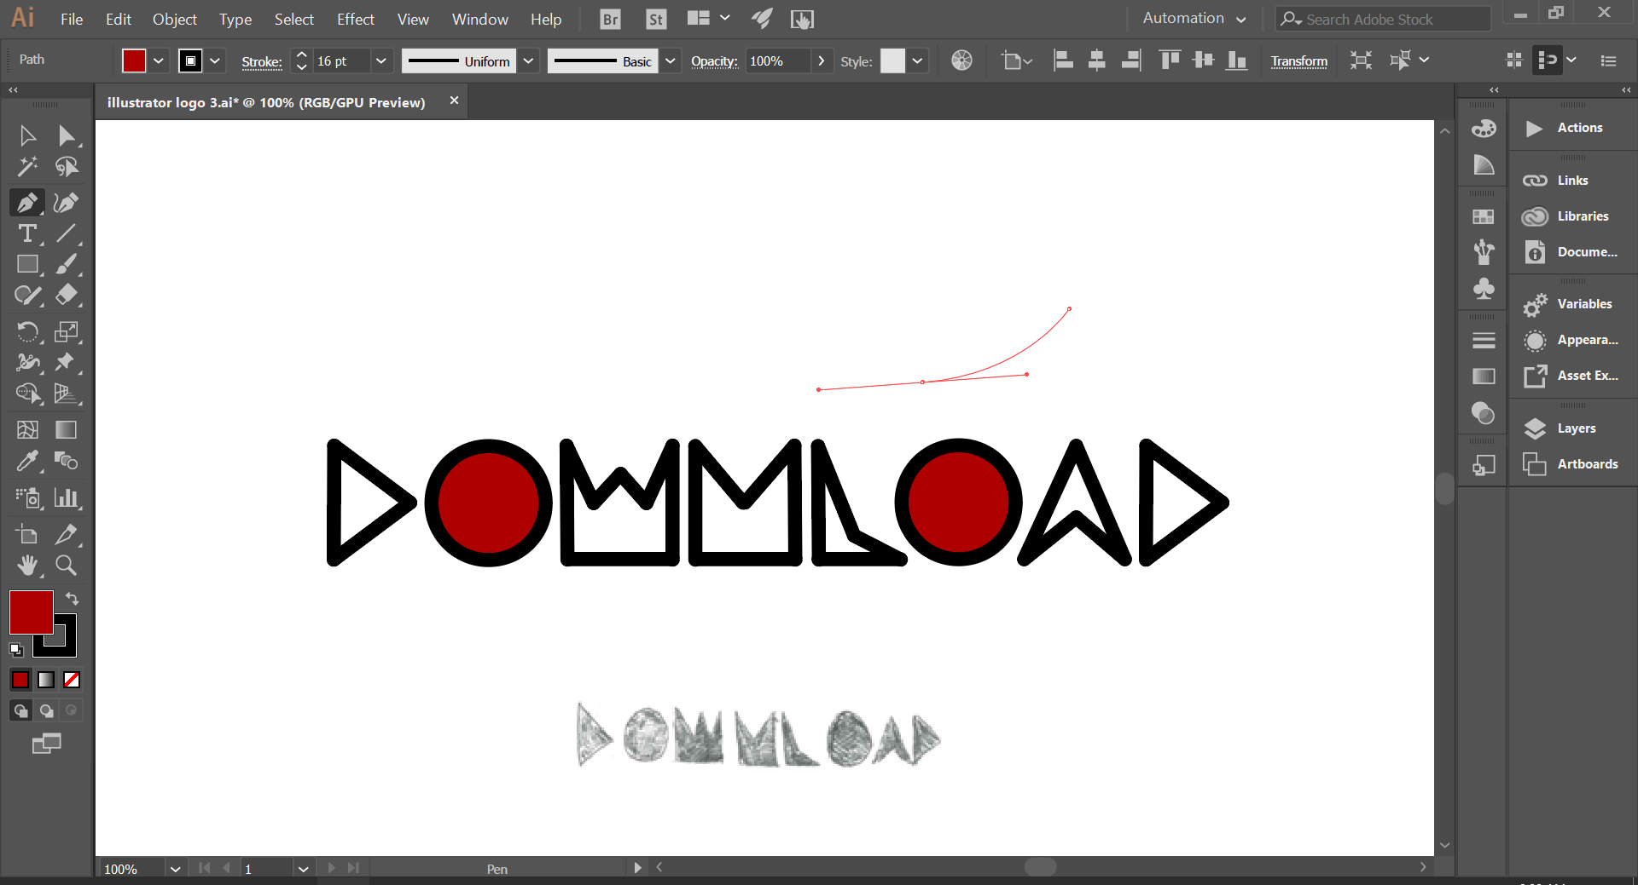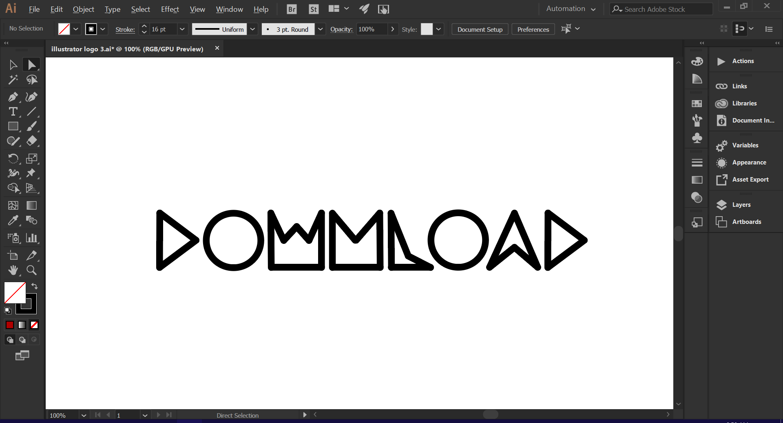

Here is the start of the bubble that encloses the text. I used the **pen tool**, and to create the curvature I held left click after I selected where the line would go to. By draging the mouse it changes the shape of the curve.

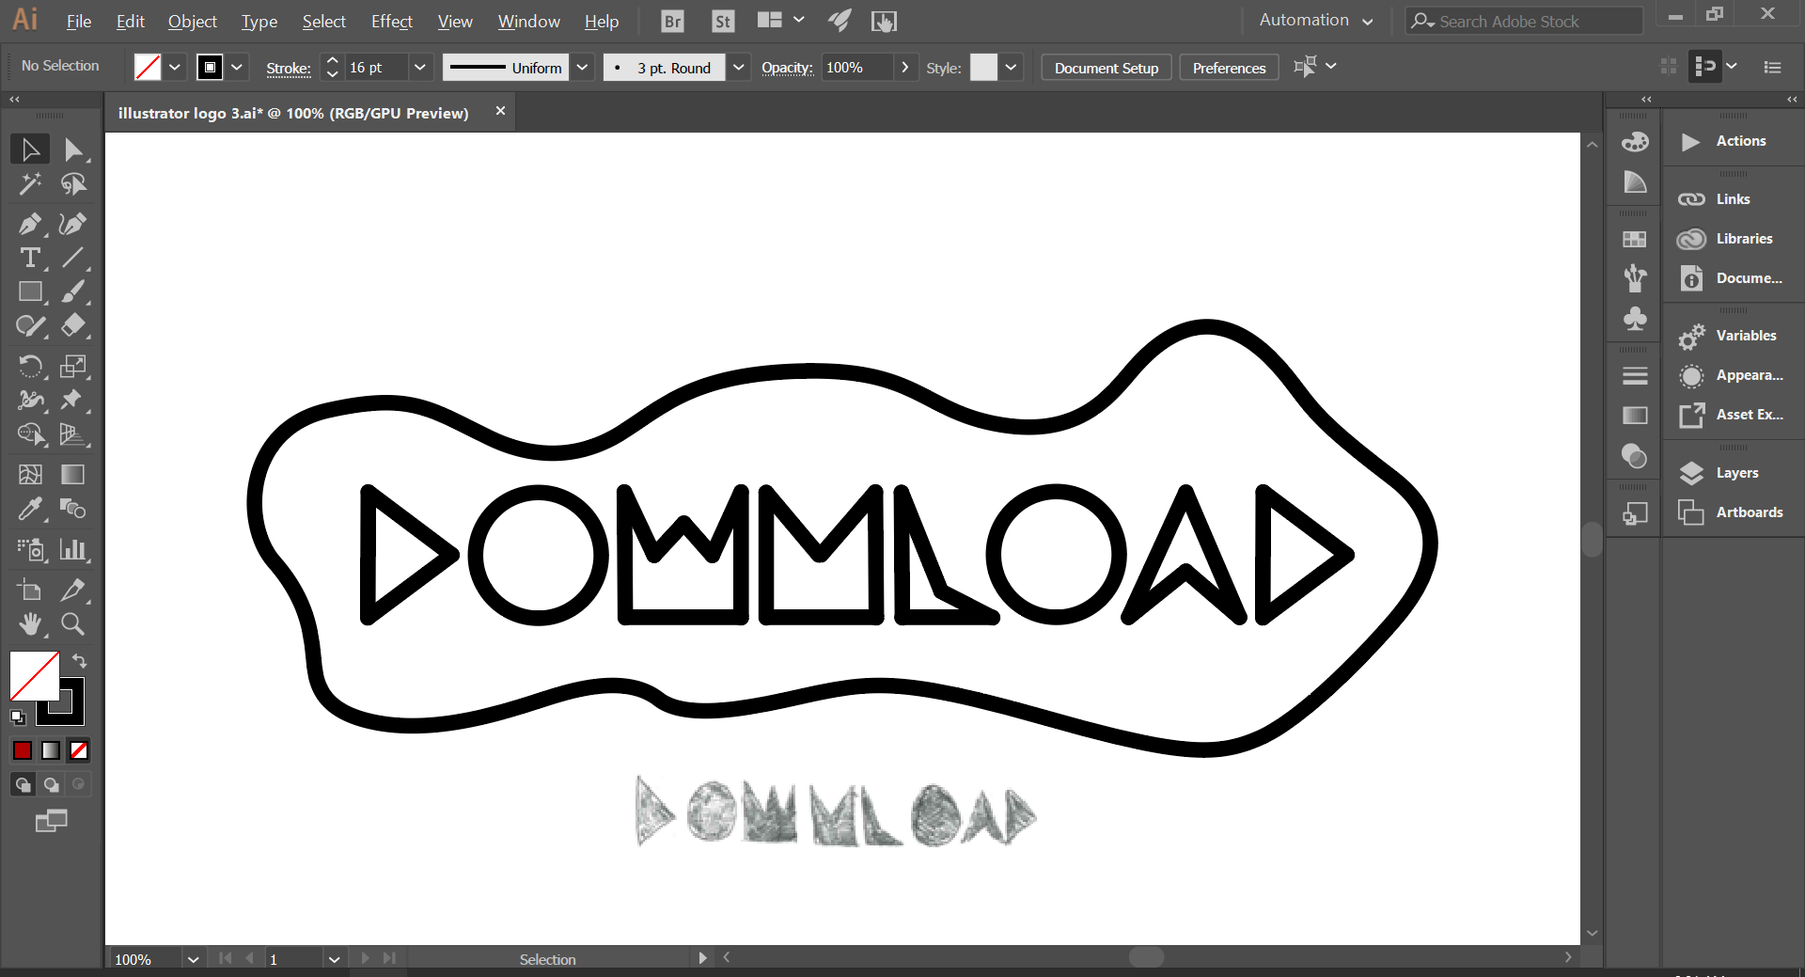

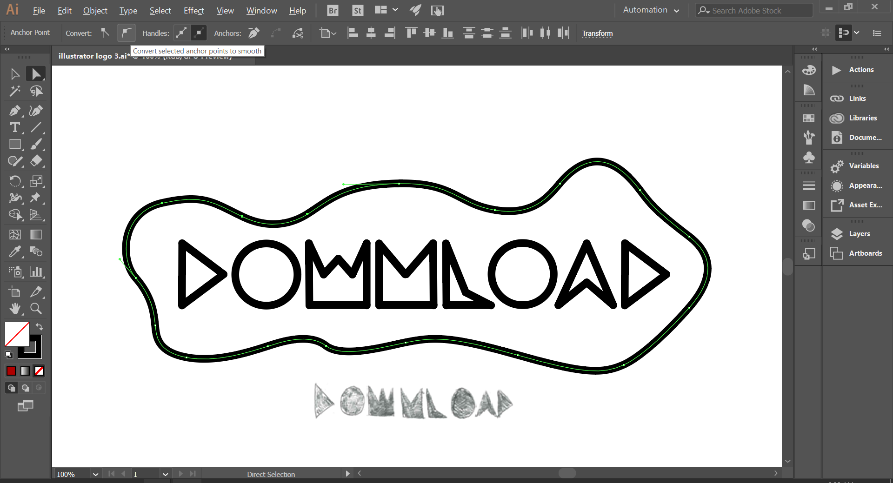

To smooth out the bubble’s lines, I selected the **direct selection tool**, and highlighted parts of the bubble. Then, I pressed the “**convert selected anchor points to smooth**” option at the top of the screen which smoothed out the lines and removed any jaggedness. I did this for all parts of the bubble

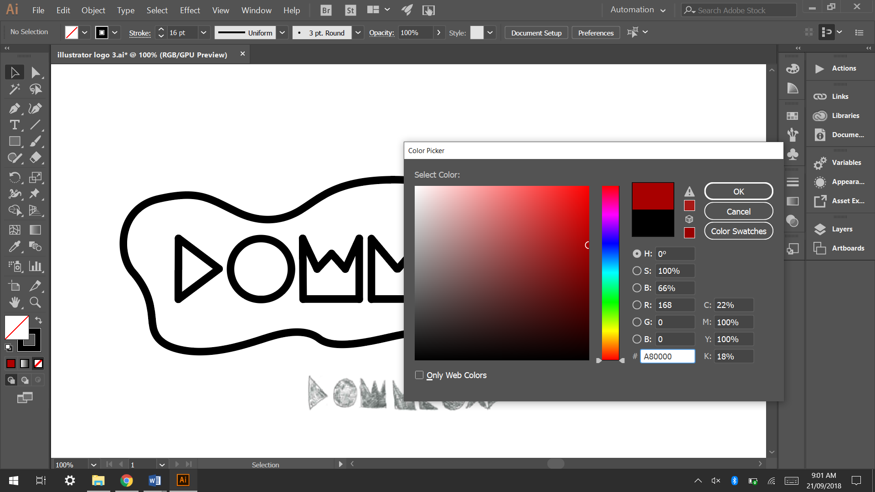

After this I selected a colour that would suit the target audience. I elected for dark red, as it suits the genre of music that would be played at Download. It is also the colour that the festival already uses, and having the colour being linked to the festival will help the logo in succeeding.

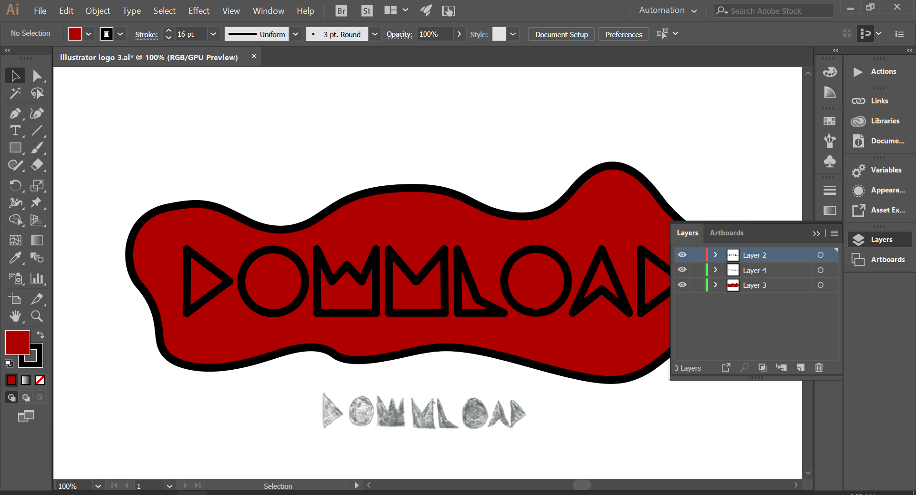

Throughout the process I ensured that the different elements of the logo were on different layers, such as the text being on a different layer to the bubble. This also meant that at the end I could remove the image that I used for inspiration but keep it in the document in case it needed again.

